PROJECT DEVELOPMENT PHASE
MODEL PERFORMANCE TEST

Date | 28 SEPTEMBER 2026
Team ID | 6ab220cfbee0b08a2d2c63cd
Project Name | Auto Ticket Classification using FLOW DESIGNER
MAXIMUM MARKS

Model Performance Testing:
S.No. | Parameter | Values | Screenshot
1 | Model Summary | ServiceNow Flow Designer automation for automatically classifying school IT support tickets based on keywords in the Short Description. The flow automatically assigns Category and Subcategory and sends an email notification to the caller. | 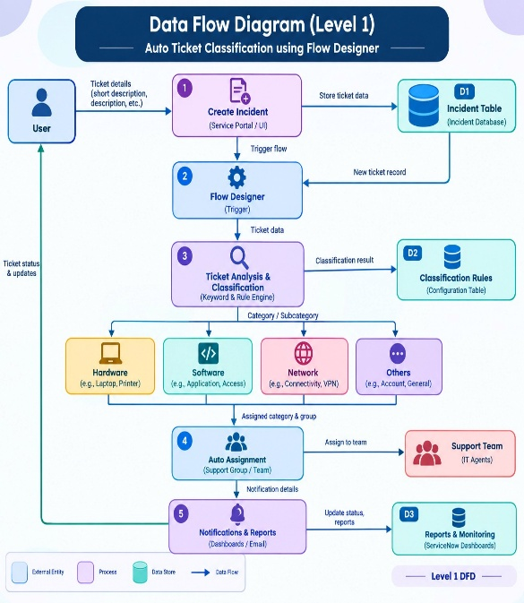
2 | Accuracy | The automation correctly classifies tickets based on predefined keywords: WiFi → Network → Wi-Fi, Projector → Hardware → Projector, Password/Login → Access → Forgot Password, and Slow/Hanging → Performance → Slow Computer. | 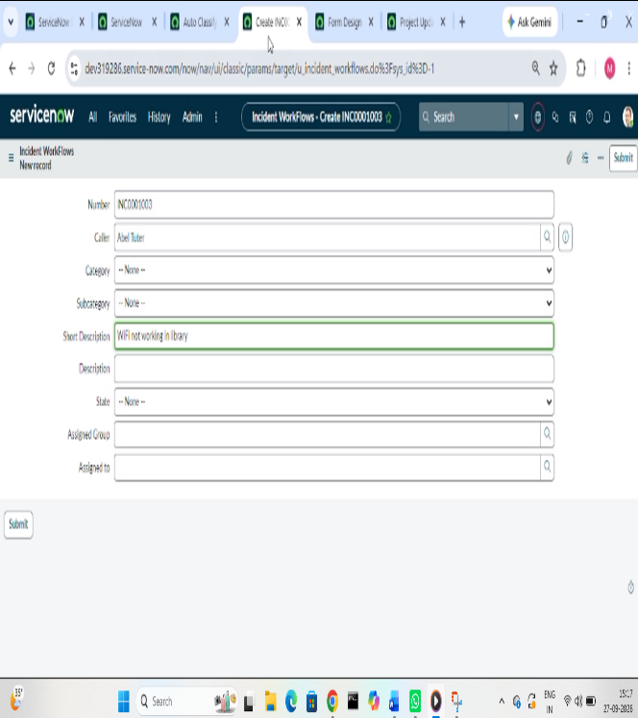
3 | Classification Result | WiFi issue: Category = Network, Subcategory = Wi-Fi. Projector issue: Category = Hardware, Subcategory = Projector. Password issue: Category = Access, Subcategory = Forgot Password. Slow computer issue: Category = Performance, Subcategory = Slow Computer. | 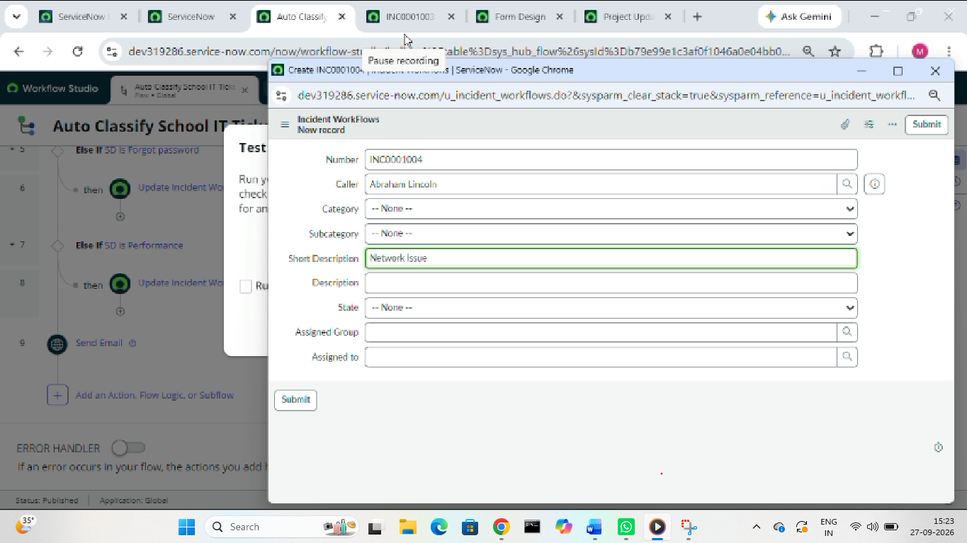
4 | Automation Result | When a new ticket is created, the Flow Designer trigger runs automatically when Category is empty and updates the ticket according to the issue description. | 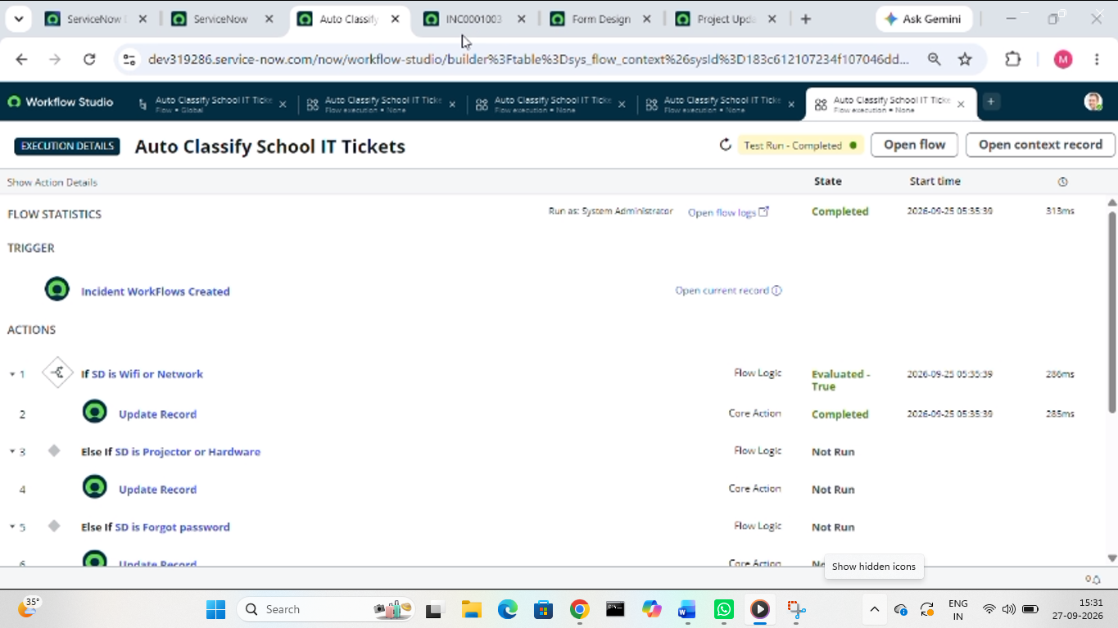
5 | Email Notification | After ticket classification, an automated email is sent to the Caller → Email with the subject “Your Request for the issue has been submitted.” | 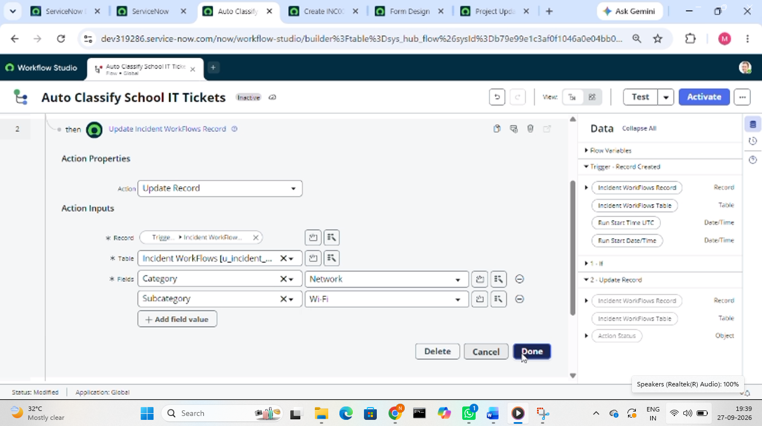
1. Model Summary
Answer to paste:
The Auto Ticket Classification using Flow Designer project is a ServiceNow no-code automation solution developed for a school IT helpdesk. The system automatically analyzes the short description of an IT support ticket and identifies the appropriate Category and Subcategory. The Flow Designer uses predefined keywords such as WiFi, Projector, Password, Login, Slow, and Hanging to classify tickets automatically. It also sends an email notification to the caller after ticket creation.
2. Accuracy
Answer to paste:
The system accurately classifies IT support tickets based on predefined keywords. WiFi-related issues are classified as Network/Wi-Fi, projector issues as Hardware/Projector, password or login issues as Access/Forgot Password, and slow or hanging computer issues as Performance/Slow Computer.
Don't put a percentage like 98% unless your actual project testing produced that value. The model document has 98% accuracy as an example, but your project document does not provide an accuracy percentage.
3. Classification Result
Input / Issue | Category | Subcategory
WiFi not working | Network | Wi-Fi
Projector not turning on | Hardware | Projector
Forgot password / Login problem | Access | Forgot Password
Slow / Hanging computer | Performance | Slow Computer

